Chapter 5, Solution 29

R₁ v_{a}
+
v_{b} - +

+
v_{i} R₂ R₂ v_{o}
- R₁
-

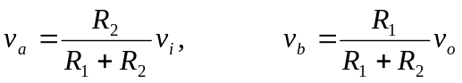

But 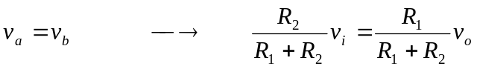
Or
